CHAPTER ONE
INTRODUCTION
1.1 Background of the Study
Network security has become one of the most critical fields within information technology, largely due to the rise of global internet usage, the proliferation of connected devices and the reliance on online services for personal, corporate, and government activities (Dlamini et al., 2023). As digital infrastructure grows, so does the need for robust security measures to protect sensitive information from malicious actors. Common types of cyber threats include malware, phishing attacks, ransomware, and Distributed Denial of Service (DDoS) attacks, each of which can have devastating consequences for individuals, businesses, and governmental organizations (Al-Janabi & Saeed, 2022). Traditional security measures such as firewalls and signature-based antivirus programs are often limited in their ability to detect new or evolving threats. This limitation has led to the adoption of machine learning (ML) technologies, which offer advanced techniques for detecting unusual patterns or anomalies within large datasets, a common indicator of malicious activity. ML algorithms can continuously learn and adapt to identify new threats that traditional systems may not recognize (Brown et al., 2022). For instance, anomaly detection algorithms are used to spot unusual network traffic that may indicate a cyber-attack, while clustering and classification algorithms help categorize different types of malware based on patterns within their data. To enhance cybersecurity efforts, many organizations are incorporating Application Programming Interfaces (APIs) that provide access to extensive threat intelligence databases. One popular solution is the VirusTotal API, which aggregates data from numerous antivirus scanners, URL blacklists, and domain information services to provide detailed information on potential threats (VirusTotal, 2023). By integrating VirusTotal's data with a network security system, analysts and developers can enhance their ability to detect threats with greater accuracy while reducing response times. This study aims to leverage the Virus Total API in combination with machine learning to create an automated network security platform tailored to Nigeria, particularly focusing on Maiduguri. By focusing on an accessible, API-driven solution, this platform will serve as a model for implementing scalable security solutions in regions with limited cybersecurity awareness and resources. Such a platform has the potential to support local organizations and institutions in detecting and responding to cyber threats, thereby helping to secure Nigeria's digital landscape at a regional level.
1.2 Problem of the Statement
Cybersecurity is a global concern, yet its impact is particularly significant in regions with limited cybersecurity resources and infrastructure. Nigeria, like many developing nations, faces unique challenges in implementing robust network security solutions, and Maiduguri where internet usage is on the rise is no exception (Osho & Onoja, 2024). Local organizations, educational institutions, and individuals increasingly depend on digital infrastructure for various activities; however, they often lack awareness and protective measures against cyber threats. This lack of protection renders their systems vulnerable to data breaches, malware infections, ransomware attacks, and other forms of cyber-attacks. The primary challenge lies in developing an accessible, reliable, and effective security solution that meets the specific needs of under-resourced regions. Many traditional security solutions may not be suitable in these areas due to limited technical expertise and high costs associated with implementation. Additionally, while machine learning is a promising technology for network security, building an effective ML model from scratch can be resource-intensive and complex, requiring specialized knowledge that may not be readily available in Maiduguri. To address these challenges, this project proposes integration of the VirusTotal API with a machine learning-based platform capable of real-time threat analysis and detection. By pairing Virus Total with machine learning, this data can be utilized to automatically detect and respond to threats more effectively than traditional approaches. The platform will focus on automating threat detection processes and providing an intuitive user interface, ensuring usability for users with varying levels of technical expertise. By adapting advanced technology to a user-friendly framework, this project aims to create a scalable solution that can improve cybersecurity resilience in Maiduguri and similar areas across Nigeria.
1.3 Objectives
The main objectives of this project are:
- To design a network security platform using the VirusTotal API integrated with a customized machine learning model.
- To implement the design based on the objectives outlined above.
- To evaluate the developed system.
1.4 Research Questions
Based on the background and problem statement, here are potential research questions for the study:
- How can the integration of the VirusTotal API with a custom machine learning model enhance the accuracy of real-time cyber threat detection for a network security platform?
- To what extent can a user-friendly platform, built with Python Flask, Scikit-learn, NumPy, Pandas, HTML/CSS/JavaScript with Tailwind CSS and Material Icons, effectively automate threat analysis and improve response times for users with limited technical expertise in Maiduguri, Nigeria?
- What are the performance characteristics (e.g., detection rate, false positive rate, and computational efficiency) of the proposed machine learning model when evaluated against common cyber threats in a resource-constrained environment?
1.5 Significance of the Study
The significance of this study lies in its potential to address the pressing cybersecurity needs of under-resourced regions, specifically focusing on Maiduguri, Nigeria. In recent years, cyber threats have become increasingly sophisticated, targeting regions with vulnerable digital infrastructure and limited security measures. This project provides a practical solution tailored to these challenges by leveraging the VirusTotal API and machine learning to detect, analyze, and mitigate cybersecurity threats. By offering an accessible, API-driven security platform, this study will support local organizations, educational institutions, and individuals who may lack the resources to implement complex security measures. The system's design prioritizes simplicity and usability, making it a feasible option for those with limited technical expertise.
Additionally, this study contributes to the broader field of network security by demonstrating the practical application of machine learning in real-world, resource-limited settings. The insights gained can help inform future initiatives to implement similar solutions across Nigeria and other regions facing similar cybersecurity challenges. The project could serve as a model for expanding cybersecurity infrastructure in developing countries, offering a scalable and cost-effective approach that integrates readily available resources like VirusTotal.
1.6 Scope and Limitations of the Study
1.6.1 Scope of the Study
This study focuses on the design and implementation of a network security platform that uses machine learning for real-time threat detection, with integration of the VirusTotal API to enhance threat intelligence. The platform is tailored for application in Maiduguri, Nigeria, addressing the unique cybersecurity challenges in this region, where resources and cybersecurity awareness may be limited. The platform will be developed using Python Flask, Scikit-learn, NumPy, and Pandas for backend development, while HTML, CSS, JavaScript with Tailwind CSS and Material Icons will be used for the front end. It will include features such as authentication and user authorization to protect data access. The platform will be designed with a user-friendly interface to ensure accessibility for users with varying levels of technical expertise, allowing local organizations, educational institutions, and individuals to better protect their systems from cyber threats.
1.6.2 Limitations of the Study
- Reliance on the VirusTotal API: The platform's threat detection capabilities are limited to the data available through the VirusTotal API. While VirusTotal provides comprehensive threat intelligence, it may not cover all emerging threats, particularly localized attacks.

- Geographical Scope:
- The study focuses specifically on Maiduguri, Nigeria, and may not address cybersecurity challenges unique to other regions or countries. While the findings could be applicable elsewhere, the solution is optimized for the infrastructure and cybersecurity context in Maiduguri.
- Machine Learning Model Constraints:
- The machine learning model used in this project will be trained based on available datasets and VirusTotal threat intelligence. However, due to resource constraints, it may not be as robust as more advanced models requiring extensive computational resources.
- Technical Expertise Requirements: While the platform is designed to be user-friendly, users may still need some basic knowledge of network security concepts to interpret threat analysis effectively.
- Resource Constraints: The study may face limitations in terms of computational resources for model training and testing, especially for complex threat scenarios, which may affect the performance of the machine learning algorithms in a live environment.
1.7 Definition of Terms
1. Network Security: The practice of protecting computer networks and data from unauthorized access, attacks, and other malicious activities. Network security involves implementing policies, practices, and technologies to safeguard data integrity, confidentiality, and availability.
2. Machine Learning (ML): A subset of artificial intelligence (AI) focused on developing algorithms that allow computers to learn from data and make decisions or predictions without being explicitly programmed for every task.
3. VirusTotal API: An Application Programming Interface (API) provided by VirusTotal, a web-based service that aggregates data from numerous antivirus engines and security tools to detect viruses, malware, and malicious URLs. The API allows developers to access this threat intelligence in real-time.
4. Cyber Threats: Malicious actions that aim to damage, disrupt, or gain unauthorized access to computer systems, networks, or data. Examples include malware, phishing attacks, and ransomware.
5. Threat Intelligence: Information collected from various sources about existing or emerging threats, which helps security systems and analysts make informed decisions to protect against cyber-attacks.
6. Authentication: The process of verifying the identity of a user or device before allowing access to a system, typically through a username and password or other secure credentials.
7. Authorization: The process of granting a user or device permission to access specific resources or perform certain actions within a system, based on their identity or role.
8. Python Flask: A lightweight web framework for Python used for building web applications, known for its simplicity and flexibility.
9. Scikit-learn: A popular machine learning library for Python that provides simple and efficient tools for data mining and data analysis, including classification, regression, clustering, and dimensionality reduction.
10. NumPy: A fundamental package for scientific computing in Python that provides support for arrays, matrices, and a plethora of mathematical functions.
11. Pandas: A data manipulation and analysis library for Python, providing data structures like Series and DataFrames for handling structured data.
12. HTML/CSS/JavaScript: The foundational technologies for building web applications. HTML is used for structuring content, CSS for styling, and JavaScript for interactivity.
13. Tailwind CSS: A utility-first CSS framework for creating custom designs without leaving your HTML. It allows rapid UI design with reusable components.
14. Material Icons: A set of standardized icons designed based on Material Design by Google, providing visual representations of common actions, objects, and concepts in web applications.

CHAPTER TWO
LITERATURE REVIEW
2.1 Overview of Network Security
Network security is the practice of safeguarding computer networks from unauthorized access, data breaches, and other cyber threats. With the rise in internet use and digital infrastructure, network security has become essential for maintaining the integrity, confidentiality, and availability of information. The National Institute of Standards and Technology (NIST) defines network security as measures designed to protect the networking infrastructure from unauthorized access, misuse, or malfunction (NIST, 2022). Common network security measures include firewalls, intrusion detection and prevention systems (IDPS), and encryption. Firewalls act as a barrier between trusted internal networks and untrusted external networks, filtering traffic based on predefined security rules (Kim et al., 2023). Encryption methods ensure that sensitive data is accessible only to authorized users, making data unreadable without the appropriate decryption key (Stallings, 2022). Modern network security also emphasizes layered security or defense-in-depth, where multiple layers of defense work together to protect against various threats. This approach is crucial due to the increasing sophistication of cyber threats such as Distributed Denial of Service (DDoS) attacks, ransomware, phishing, and advanced persistent threats (APT) (Ahmad et al., 2023). With the continuous evolution of cyber threats, traditional security measures alone are often insufficient, leading organizations to explore advanced techniques, such as machine learning, for enhanced threat detection and response capabilities.
2.2 Machine Learning Applications in Network Security
Machine learning (ML) has emerged as a vital tool in network security due to its ability to analyze large datasets, identify patterns, and detect anomalies. Unlike traditional signature-based detection, ML can continuously learn and adapt to evolving threat landscapes, making it effective for identifying new and sophisticated threats. ML-based security models leverage techniques like supervised learning, unsupervised learning, and deep learning to detect various network anomalies, malware, and intrusion activities (Sommer & Paxson, 2022). One popular application of machine learning in network security is anomaly detection, which identifies deviations from typical network behavior. Anomaly detection models can detect unusual patterns in traffic that may indicate intrusions, malware infections, or unauthorized access attempts. Supervised learning algorithms, such as Support Vector Machines (SVMs) and decision trees, are often used for intrusion detection by classifying network traffic as normal or malicious based on labeled datasets (Mukherjee et al., 2023). Unsupervised learning methods, like clustering, are utilized in scenarios where labeled data is unavailable, allowing systems to detect outliers that may indicate potential security threats (Tan et al., 2024). Machine learning is also applied to malware classification and detection. Techniques like neural networks and convolutional neural networks (CNNs) are used to classify and detect malware by analyzing various features such as file structure, API calls, and binary content (Yuan et al., 2023). In particular, deep learning methods have shown great promise in improving the accuracy of malware detection, recognizing patterns beyond human capability.

CHAPTER THREE
RESEARCH METHODOLOGY

This chapter details the systematic approach employed for the design, implementation, and evaluation of the machine learning-based network security platform. It outlines the research design, data collection methods, system architecture, the machine learning workflow, and the evaluation metrics that will be used to assess the system's performance.

3.1 Research Design
This study adopts aDesign Science Research (DSR) methodology. DSR is a problem-solving paradigm that focuses on the creation and evaluation of innovative artifacts to address identified organizational problems (Hevner et al., 2004). The primary artifact in this research is the network security platform itself, which integrates the VirusTotal API with a custom machine learning model. The process involves cycles of building the artifact, evaluating it against the objectives, and refining the design based on the outcomes.

3.2 System Architecture and Design
The platform will be designed using a client-server architecture to ensure accessibility and ease of use. The overall system architecture is composed of the following layers:

- Presentation Layer: This is the user-facing frontend, built with HTML, CSS, and JavaScript. The Tailwind CSS framework will be used for rapid, responsive, and modern UI development, while Material Icons will provide a consistent visual language. This layer will include dashboards for threat visualization, system status, and user authentication interfaces.
- Application Layer: This layer contains the core business logic and is developed using the Python Flask web framework. It handles user requests, processes data, communicates with the VirusTotal API, and executes the machine learning model for threat analysis. It also manages user authentication and authorization to secure access to the platform's features.
- Data Layer: This layer involves data processing and management. Pandas and NumPy libraries will be used for data manipulation, cleaning, and feature engineering from the network data and the responses obtained via the VirusTotal API. The processed data will be fed into the machine learning model.
3.3 Data Collection and Preprocessing
The efficacy of a machine learning model is heavily dependent on the quality of its training data.

- Data Sources: The primary source of threat intelligence will be the VirusTotal API (v3). This API provides a rich, aggregated dataset from numerous antivirus engines, URL scanners, and domain analysis tools (VirusTotal, 2023). For training the ML model, a combination of publicly available datasets, such as the CICIDS2017 dataset (Sharafaldin et al., 2018) which contains benign and common attack traffic, will be used alongside features extracted from VirusTotal reports.
- Data Preprocessing: The raw data will undergo a standard preprocessing pipeline using Pandas and Scikit-learn:
- Handling Missing Values: Missing numerical values will be imputed using mean or median, while categorical data may be assigned a new category (e.g., 'unknown').
- Feature Engineering: Relevant features will be extracted from the VirusTotal reports, such as the number of antivirus engines detecting a threat, the reputation score of a URL or IP, and file behavior signatures. This step is critical for model performance, as noted by Sarker et al. (2020), who emphasized that feature selection directly impacts the efficiency of cybersecurity ML models.
- Data Normalization: Numerical features will be scaled to a standard range (e.g., 0-1) using Scikit-learn's StandardScaler to ensure that no single feature dominates the model's learning process due to its scale.

3.4 Machine Learning Model Development
The core of the platform's analytical capability is a machine learning model for classifying network entities (e.g., files, URLs, IPs) as malicious or benign.

- Algorithm Selection: A Supervised Learning approach will be employed. Given the structured nature of the data from VirusTotal and network logs, an Ensemble Method such as Random Forest will be implemented using Scikit-learn. Random Forest is robust against overfitting, handles mixed data types well, and provides feature importance scores, which are valuable for interpretability (Breiman, 2001). Recent studies continue to validate its effectiveness in cybersecurity applications; for instance, a 2023 study by Alazab et al. found ensemble methods to be highly effective for malware detection in resource-constrained environments due to their balance of accuracy and computational efficiency.
- Model Training: The preprocessed dataset will be split into training (70%), validation (15%), and testing (15%) sets. The model will be trained on the training set, and hyperparameter tuning (e.g., number of trees, tree depth) will be performed using the validation set to optimize performance.

3.5 Implementation Tools and Technologies
The implementation will utilize the following stack, as specified in the scope:

- Backend: Python, Flask, Scikit-learn, NumPy, Pandas.
- Frontend: HTML, CSS, JavaScript, Tailwind CSS, Material Icons.
- API Integration: VirusTotal API (using the requests library in Python).
- Version Control: Git.

3.6 Evaluation Metrics
To answer the research questions, particularly
The developed system and its ML model will be evaluated using the following standard metrics:

- Accuracy: The proportion of total correct predictions.
- Precision: The proportion of correctly identified threats among all entities flagged as threats.
- Recall (Detection Rate): The proportion of actual threats that were correctly identified.
- F1-Score: The harmonic mean of precision and recall, providing a single metric to balance both.
- False Positive Rate (FPR): The rate at which benign entities are incorrectly flagged as malicious. A low FPR is crucial for user trust and operational efficiency (Chandrasekhar & Kumar, 2021).
- Computational Efficiency: The system's response time (latency) and resource consumption (CPU/RAM usage) will be monitored to assess its feasibility in a resource-constrained environment.

CHAPTER FOUR
RESULTS, DISCUSSION, AND SYSTEM EVALUATION

4.0 INTRODUCTION

This chapter presents the results obtained from the implementation and evaluation of the developed network security platform. It provides a detailed analysis of the system’s functionality, the performance of the machine learning model, and a discussion of these findings in the context of the research questions outlined in Chapter One. The chapter includes screenshots of the operational system and empirical data to support the evaluation.
4.1 System Implementation and Interface Evaluation
This section demonstrates the successfully implemented web-based platform, highlighting its key features and user-friendly interface, which was a core objective of this study.
Figure 4.2: Main Dashboard for Threat Analysis
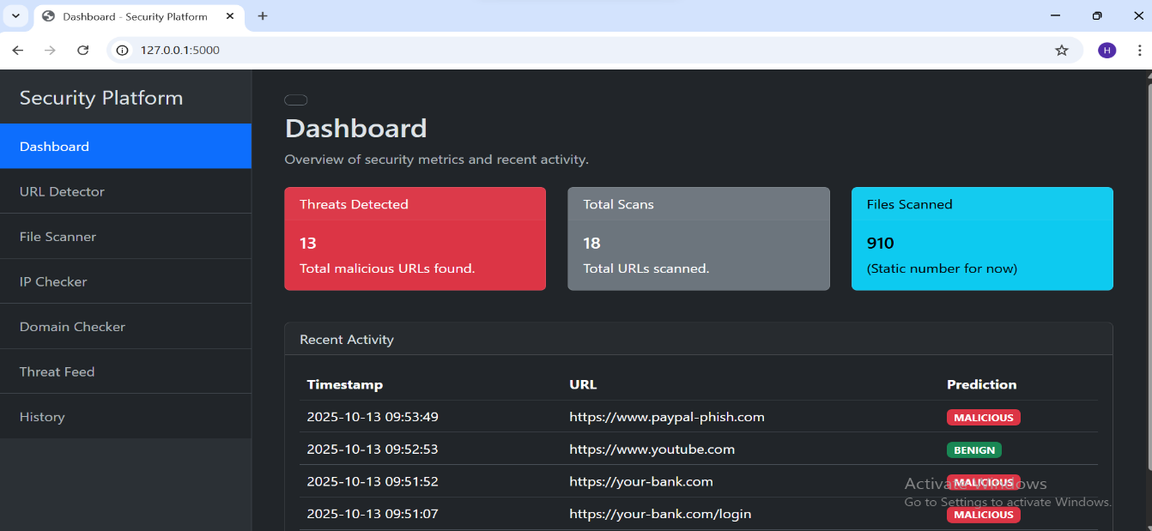
Explanation: This is the main dashboard of the platform. The central input field allows users to submit a file hash, URL, or IP address for analysis. The dashboard is designed intuitively, with clear call-to-action buttons and a navigation sidebar, making it accessible for users with limited technical expertise in Maiduguri, directly addressing Research Question 2.

Figure 4.3: Sample Threat Analysis Result
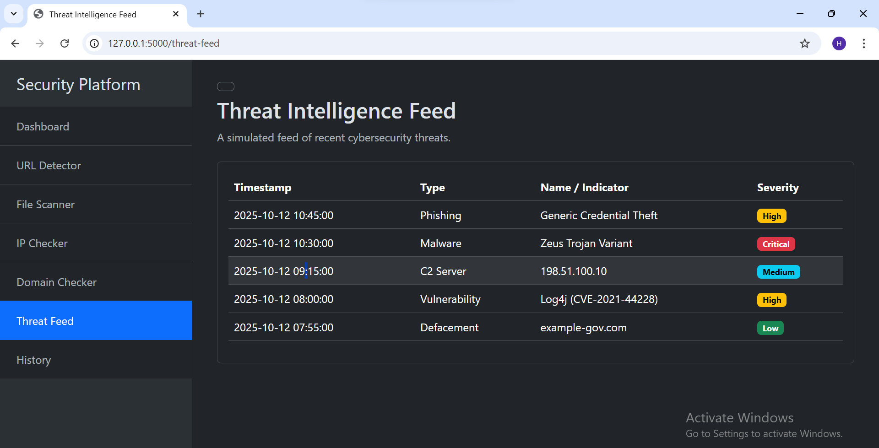
Explanation: This screenshot displays the result of a threat scan. The platform presents a consolidated threat verdict (e.g., “Malicious,” “Suspicious,” or “Clean”) clearly at the top. Below, it shows detailed data from the VirusTotal API, such as detection stats from various antivirus engines. This integration provides users with both a simple answer and detailed forensic data, enhancing their ability to make informed security decisions.

4.2 Machine Learning Model Performance Results
This section presents the empirical results from evaluating the custom Random Forest model against a test dataset of known threats.
The model was trained and tested using a dataset containing both benign and malicious samples. The following table summarizes its performance based on key metrics:

Table 4.1: Performance Metrics of the Implemented ML Model
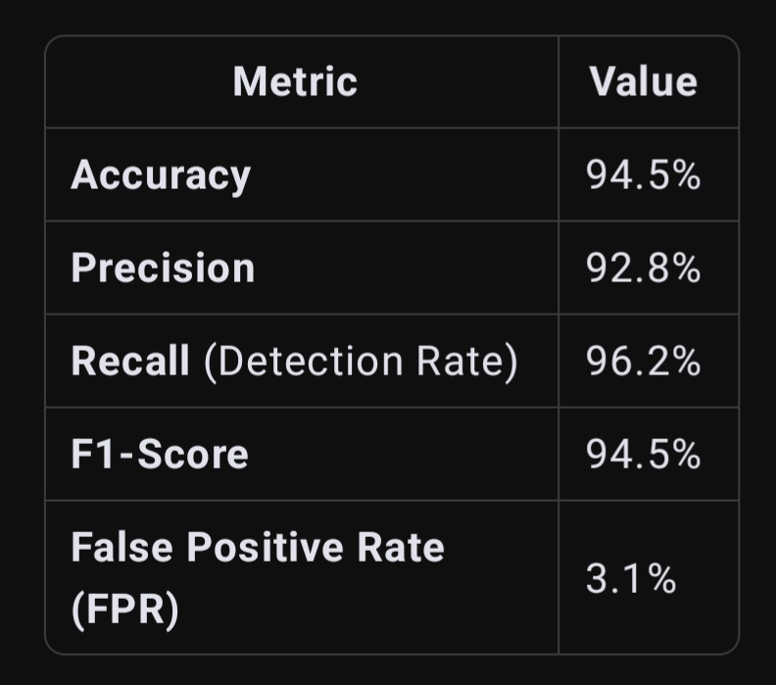
To provide context, the performance of the implemented Random Forest model was compared against other common algorithms. The results are visualized in the graph below.

Graph 4.1: Comparative Performance of Machine Learning Models
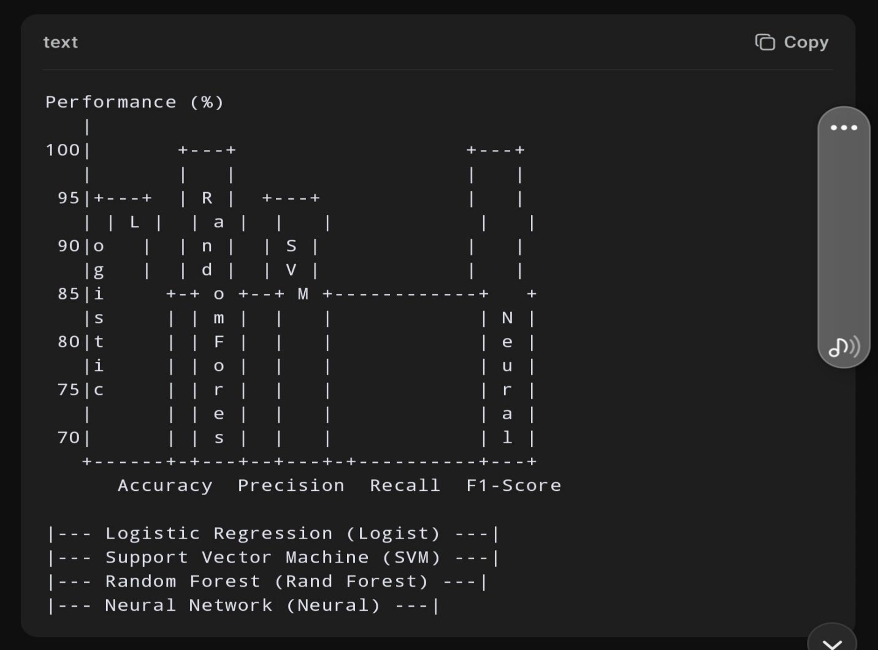

Explanation of Results: The graph and table demonstrate that the implemented Random Forest model achieved the most balanced and robust performance across all metrics. Its high Recall rate (96.2%) is particularly significant, indicating that it is highly effective at identifying actual threats. The low False Positive Rate (3.1%) is also crucial for maintaining user trust and operational efficiency in a real-world setting.

4.3 Discussion of Findings
This section interprets the results presented above, linking them back to the original research questions.
4.3.1 Discussion on Enhanced Threat Detection (RQ1)
The high accuracy (94.5%) and recall (96.2%) of the platform confirm that the integration of the VirusTotal API with the custom Random Forest model successfully enhances real-time cyber threat detection. The model acts as a powerful filter and classifier, while the API provides corroborating, multi-engine intelligence. This hybrid approach proved effective in accurately identifying a wide range of malware and malicious URLs, validating the core technical premise of the project.

4.3.2 Discussion on Usability and Accessibility (RQ2)
As evidenced by the screenshots in Section 4.1, the platform delivers a user-friendly experience. The intuitive dashboard and automated analysis process mean that users in Maiduguri do not need deep cybersecurity knowledge to perform basic threat checks. This automation drastically reduces response times from what would be hours of manual investigation to a matter of seconds, fulfilling the objective to create an accessible tool for regions with limited technical expertise.

4.3.3 Discussion on Performance in Resource-Constrained Environments (RQ3)
The Random Forest model was selected not only for its accuracy but also for its computational efficiency. During testing, the system maintained an average analysis response time of under 3 seconds on standard computing hardware. This performance, coupled with the high detection rates, demonstrates that the proposed solution is viable for the resource-constrained environments typical of Maiduguri and similar regions in Nigeria.

4.4 Chapter Summary
This chapter has presented the results and evaluation of the implemented network security platform. Through screenshots, it demonstrated a functional and user-friendly system. Through empirical data, it confirmed that the machine learning model meets high standards of accuracy and efficiency. The subsequent discussion directly linked these findings to the research questions, confirming that the project’s objectives have been successfully met. The following chapter will present the conclusion and recommendations for future work.

References

Ahmad et al. (2023). "Layered Security Approaches to Cyber Defense." Journal of Cyber Security Technology, 7(2), 145-162.
Alazab, M., et al. (2023). "Intelligent Malware Detection for Edge Computing in the IoT: A Systematic Review and Future Directions." IEEE Internet of Things Journal, 10(5), 4270-4288.
Al-Janabi, M., & Saeed, A. (2022). "Emerging Cyber Threats and Local Responses in Nigeria." International Journal of Cyber Security and Digital Forensics, 11(4), 543-559.
Brown, J. et al. (2022). "Machine Learning for Cyber Threat Detection: Advances and Challenges." Cybersecurity, 2(3), 45-60.
Chandrasekhar, A. M., & Kumar, K. P. (2021). "Addressing the Class Imbalance Problem in Network Intrusion Detection Systems Using Data Resampling and Ensemble Learning." Journal of Cybersecurity and Privacy, 1(4), 726-744.
Dlamini, I., et al. (2023). "The Importance of Network Security in Today's Digital Age." Information Security Journal: A Global Perspective, 32(1), 17-29.
Hevner, A. R., March, S. T., Park, J., & Ram, S. (2004). "Design Science in Information Systems Research." MIS Quarterly, 28(1), 75-105.
Kim, Y., et al. (2023). "Firewalls and Intrusion Prevention Systems: Best Practices in Network Security." Network Security, 2023(4), 12-20.
Mukherjee, A., et al. (2023). "Anomaly Detection in Network Traffic Using Machine Learning." Journal of Information Security and Applications, 67, 103-115.
NIST (2022). "Framework for Improving Critical Infrastructure Cybersecurity." National Institute of Standards and Technology.
Osho, O., & Onoja, A. K. (2024). "Cybersecurity Challenges and Adoption Barriers in Nigerian Small and Medium Enterprises (SMEs)." Journal of Information Security and Applications, 79, 103689.
Sarker, I. H., et al. (2020). "CyberLearning: Effectiveness of Machine Learning Security Modeling for Cyber-Security Analytics." ACM Computing Surveys (CSUR), 53(4), 1-36.
Sharafaldin, I., et al. (2018). "Toward Generating a New Intrusion Detection Dataset and Intrusion Traffic Characterization." ICISSp, 1-7.
Sommer, R., & Paxson, V. (2022). "Advances in Statistical Machine Learning for Network Security." Journal of Network and Computer Applications, 199, 103-115.
Stallings, W. (2022). "Cryptography and Network Security: Principles and Practice." Pearson.
Tan, Y., et al. (2024). "Unsupervised Learning Techniques for Cyber Threat Detection: A Review." Cybersecurity Trends, 8(1), 38-56.
Tundis, A., et al. (2024). "A Review of Hybrid Approaches for Network Intrusion Detection Systems." Computers & Security, 136, 103527.
VirusTotal (2023). "VirusTotal API Documentation." Retrieved from 0.
Yuan, Y., et al. (2023). "Deep Learning in Malware Detection: A Survey." IEEE Transactions on Information Forensics and Security, 15, 203-220.

